AIG CYBERSECURITY JOB SIMULATION BY FORAGE

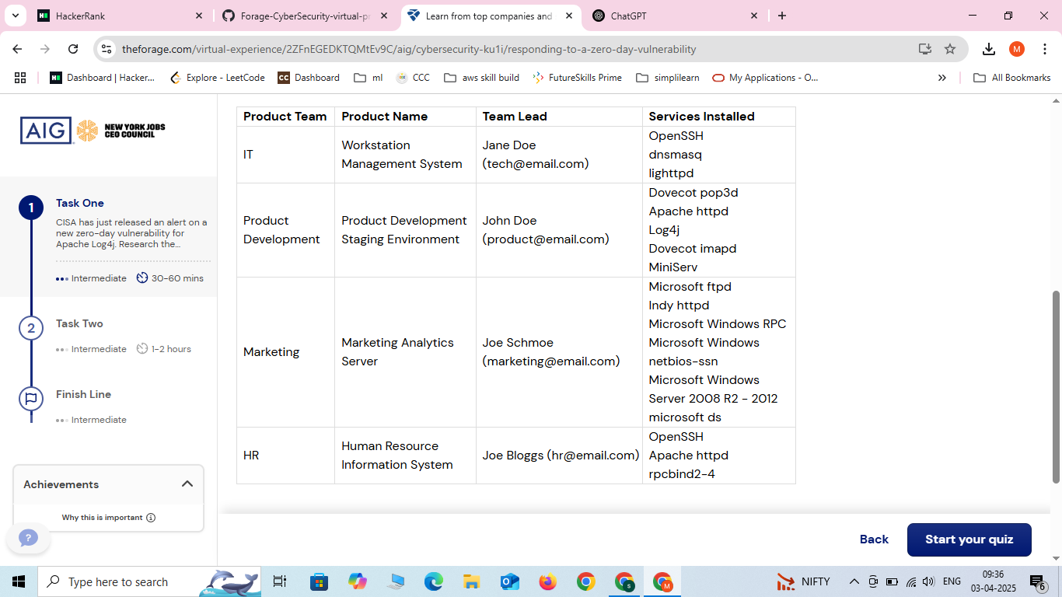

TASK 1:

email

From: AIG Cyber & Information Security Team
To: John Doe (Product Development Team)
Subject: Security Advisory concerning Log4j Vulnerability Affecting Product Development Staging Environment
—
Body:
Hello John,
AIG Cyber & Information Security Team would like to inform you that a recent Apache Log4j vulnerability (CVE-2021-44228) has been discovered in the security community that may affect the Product Development Staging Environment.
A newly identified zero-day vulnerability (CVE-2021-44228) in Log4j allows attackers to remotely execute malicious code on affected systems. This could lead to serious risks like unauthorized access, data breaches, and potential system takeovers. Unfortunately, this vulnerability is already being actively exploited.
It is categorized as High Risk Vulnerability. This vulnerability is rated 10.0 (Critical) on the CVSS scale. Hackers are actively scanning for and exploiting systems using Log4j.If left unpatched, it could expose our systems to major security threats, including ransomware and data leaks.
To mitigate this vulnerability, please take the following actions as soon as possible:
- Update Log4j immediately to version 2.17.1 or later to close the security gap.
- If updating isn’t possible right away, apply these temporary mitigations:
- Set log4j2.formatMsgNoLookups to true.
- Remove the JndiLookup class from log4-core.jar.
- Monitor logs for any suspicious activity and ensure no unauthorized access has occurred.

Could you confirm once the fix has been applied or let us know if you need any help? Please prioritize this, as it’s a critical issue that could impact security.

For any questions or issues, don’t hesitate to reach out to us.
Kind regards,
AIG Cyber & Information Security Team

